a Switchless Quad Kernal Switcher design for the C64 and C64C

User Guide
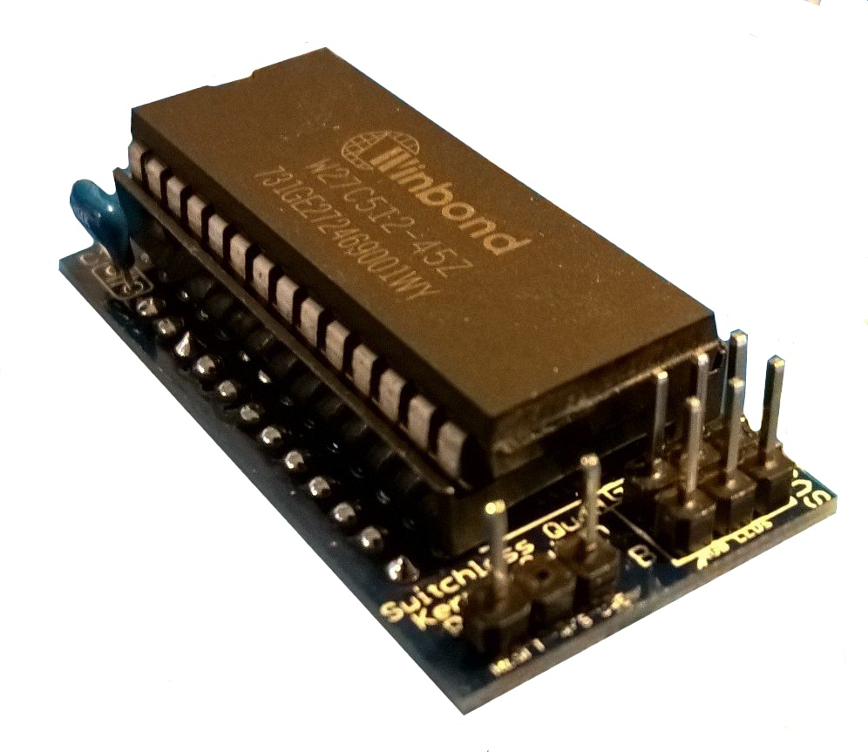

Introduction
The Switchless Quad Kernal Switcher turns your C64 into a flying raspberry flavoured pumpkin that can boost the performance of your computer. It is high on itself and makes your C64 smoke out of the I/O ports. It is UL94 rated, so no flames though. Wear eye protection. Selected Kernal is indicated with a color power indicator. Maybe you just need a 24-28 adapter, the Switchless Quad Kernal Switcher is just what you need.
There is also a C64C version, for people who are fortunate to have 250469 PCB boards. Note that some C64C looking cases may have C64 motherboards ! You have to open it up to see.
The SKS64 can also be used as a 24 to 28 pin adapter. Only sockets and the ROM is required for the adapter.

Board overview
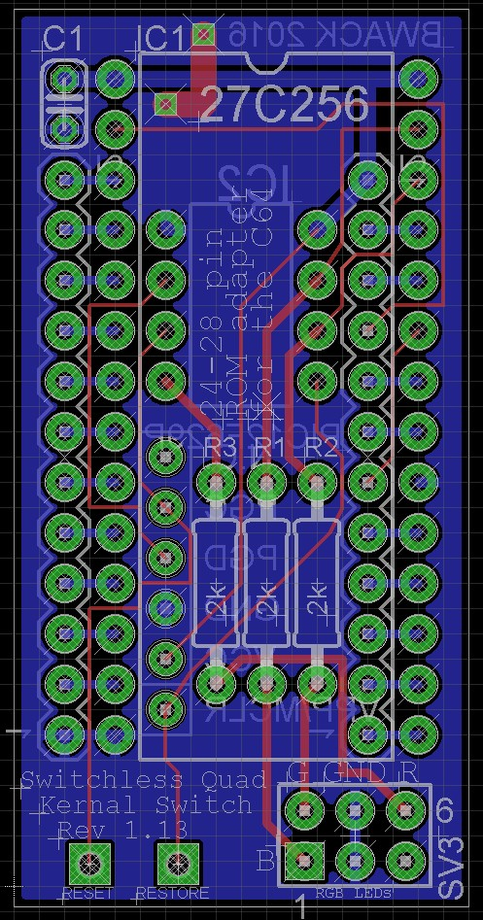
100nF decoupling capacitor
IC Socket for the EPROM
Note: Cut the surrounding solder joints flush with the pcb to get the IC socket to sit flush on the board.
Two 12 pin - pin headers
(bottom side)
IC Socket for the PIC MCU (bottom side)
ICSP Programming header
LED resistors. You might want to try a higher resistacnce on R2 because green tend to be quite bright and swomp out the other colors.

Switching Kernals
The selection mode is entered by holding RESTORE for 3 seconds, and is indicated with a slight flash of RED on the RGB LED. Be quick and continue to tap RESTORE until the desired color on the LED is shown. The computer reset after two seconds of no activity.

RESTORE as reset key
Hold the RESTORE key for 3 seconds then release. Wait two seconds for the reset.

Board Assembly
Because the board is so convoluted, the components need to be soldered in a special order to be able to reach all the solder pads. Using an IC socket for the ROM instead of precision turned socket rows is possible though time consuming, because you have to cut the solder pins flush that lay under the socket's footprint.
Here you see the board from the underside. I have inserted the IC socket that is later soldered into the C64 motherboard (longboard). 1. Start with the first 12-pin row on the left bottom side. 2. 8pin PDIP socket bottom side, 3. 28pin IC socket top-side. 4. Solder the last 12-pin row on the right bottom side. Tip! When soldering the last row of pins, attach the motherboard-ic-socket (24pin) as shown in the image to align the last row of pins before soldering (no. 4).
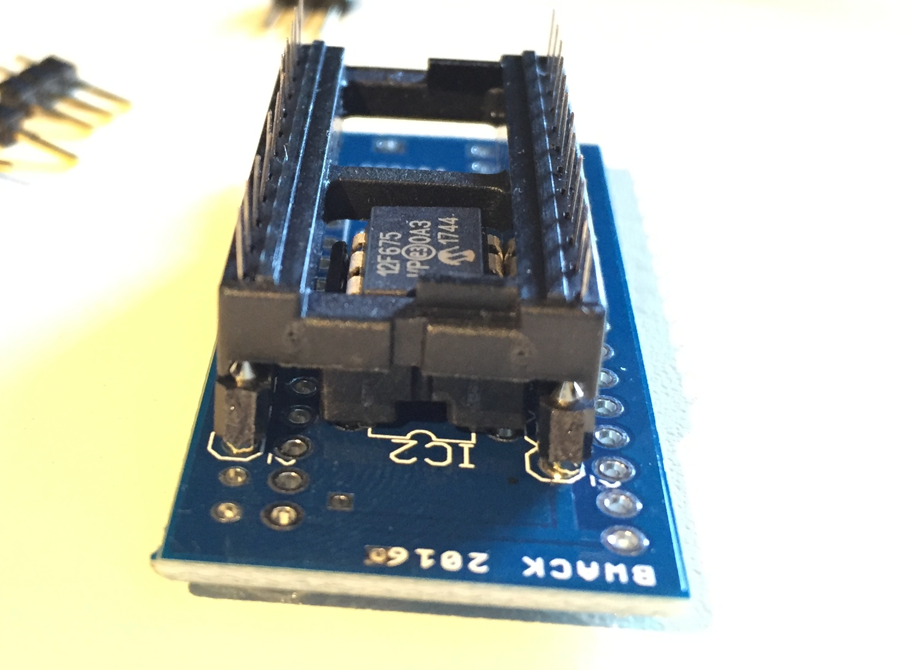
1
Soldering order numbers:
2
3
4

Installation
- Locations of the INTRES and RESTORE signals
- show images of different C64 motherboards and bubble-zoom closeups of where to attach intres and restore

TBD

The RGB LED Cable Assembly
The current selected kernal rom image is indicated with an RGB LED. RED, GREEN, BLUE and CYAN. It must ba a common cathode type*. Use the LED pinout diagram as shown below to locate the negative, red green and blue LED connections. Attach wires and use heathshrink tubing. You can see an excellent realization of this in the pictures below done by @thilographie_de . Thank you for letting me use your pictures.

The other end of the cable goes into a 2x3 female pin header. The connections for R, G and B in the pcb are noted on the silk-screen (the white text on the pcb). You can solder the wires directly onto the pcb if you like, but it is nice to be able to separate top enclosure where RGB LED is clipped into from the rest of the computer.

* A common cathode means that all cathodes are joined together. The cathode is the "negative" side of the LED. I bought it on ebay, and the product title was: "4PIN 5mm RGB LED - Tri-Colour 3 in 1 - Frosted Diffused Common Cathode".
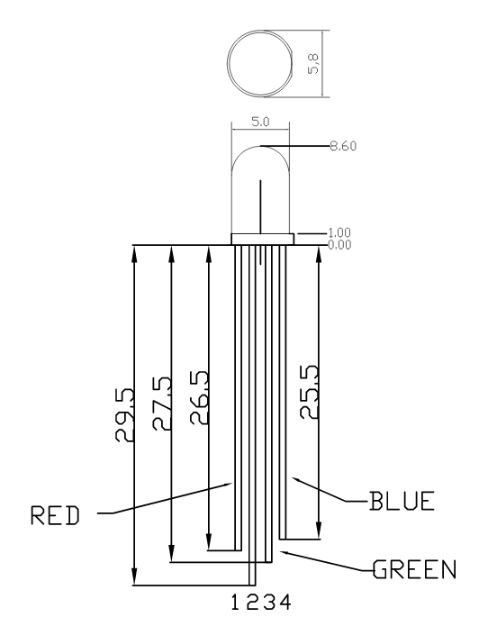
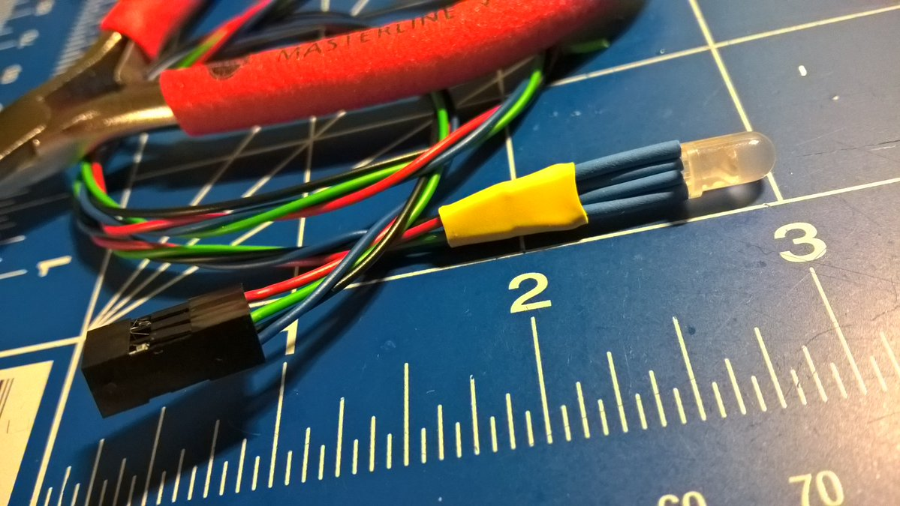
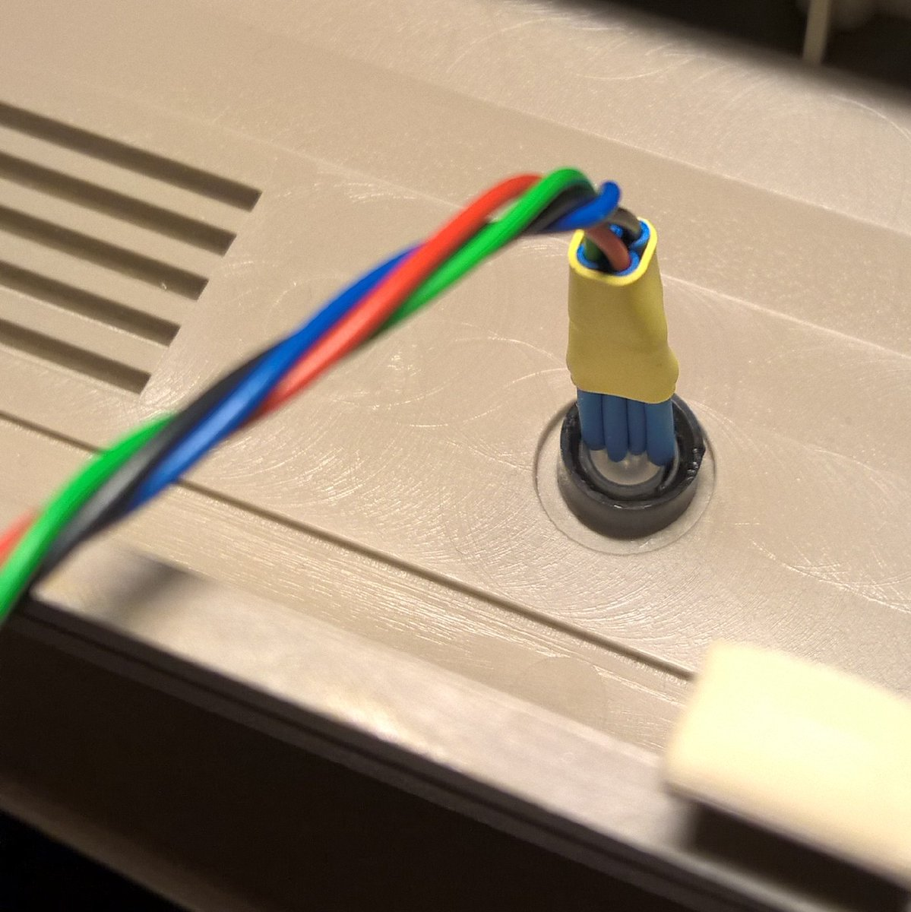
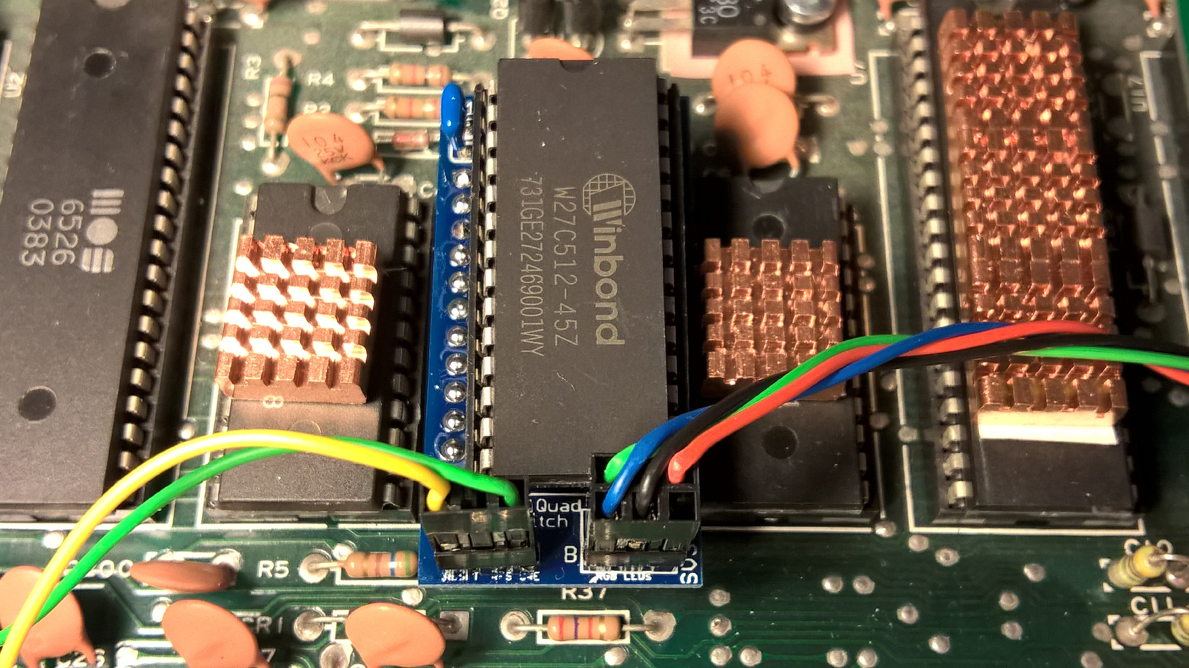

Programming the PIC microcontroller
Programming the MCU is done by loading the .hex file into your favorite PIC programmer software. The MiniPro TL866 Universal Programmer is my favorite. Clone or download the whole project to your computer first*. Locate the .hex file. There is one for PIC12F629 and one for PIC12F675. Insert the PIC onto the programmer. Then start the programming process.

- Note that it is safest to download the whole git project first and then locate the hex file from there. It has come to my attention that people have attempted to fetch only the .hex file directly of the github repository. What happens when you right click and save-as in your browser is that you actually are getting a HTML file and not the .hex file.

Alternative Firmware and single LED version
For use with existing LED, checkout tebl's github repository. His kernal switcher is based on this design and has a different firmware behaviour that suits a single LED better.
https://github.com/tebl/C64-Kernal-Switcher

